Ideation Phase
Brainstorm & Idea Prioritization Template

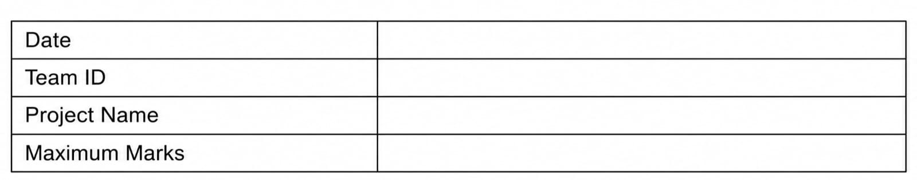
Step 1: Team Gathering, Collaboration and Select the Problem Statement

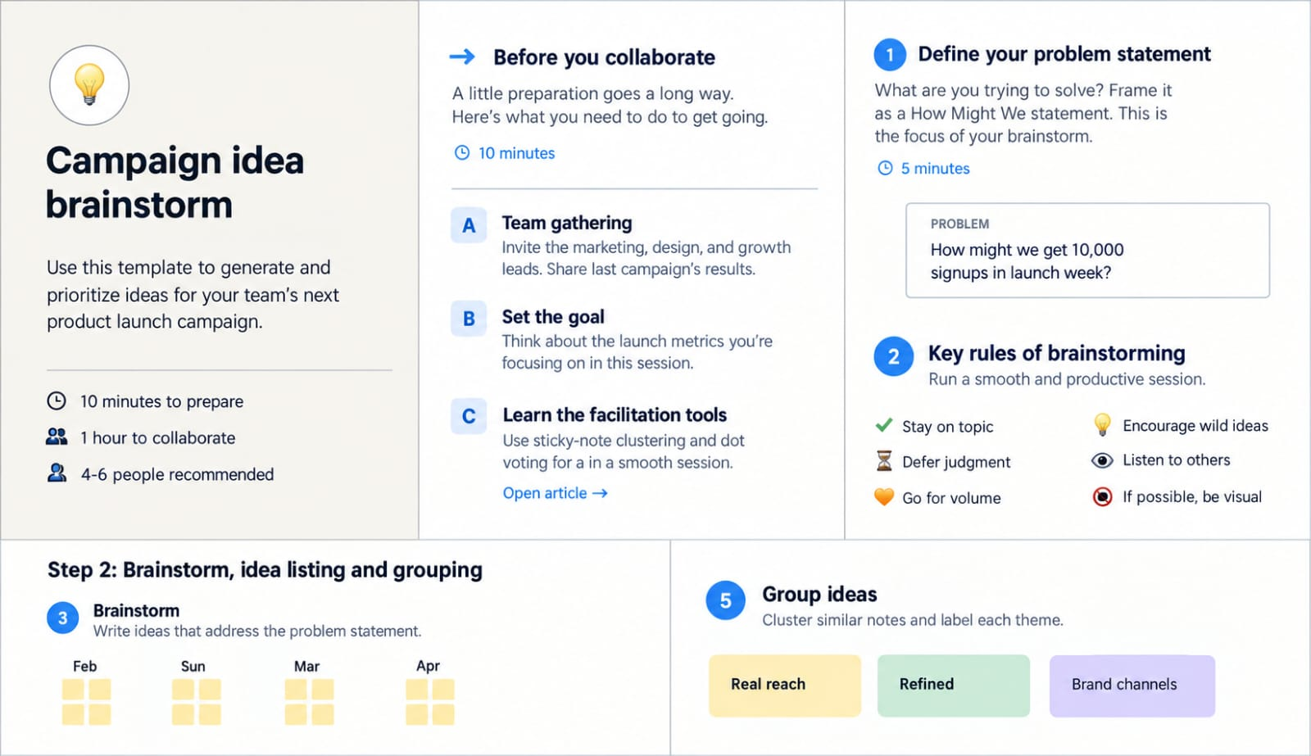

Step 2: Brainstorm, idea listing and grouping
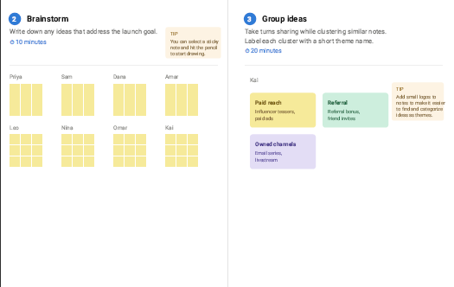

Step 3: Idea prioritization

